**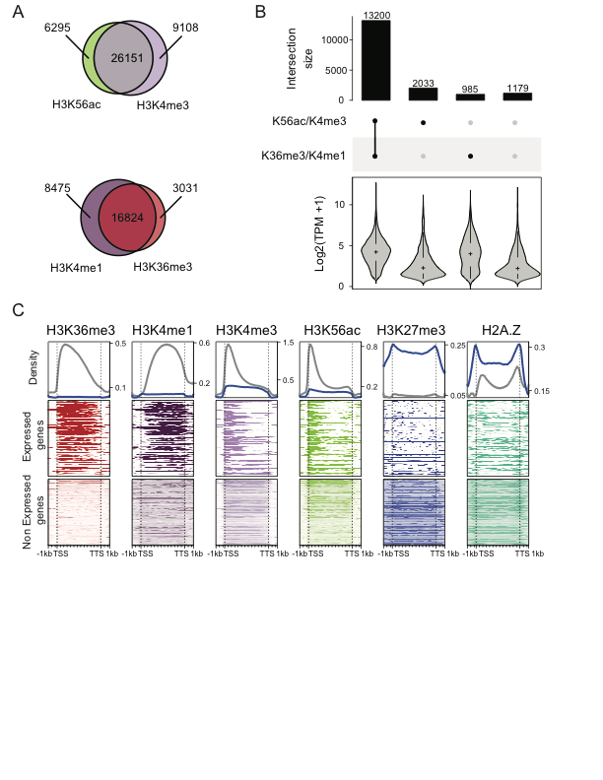**

**Supplementary Figure 1.1: The histone modification landscape of expressed and unexpressed genes in *Zea mays* ininflorescence tissue*.*** A). The overlap between enriched domains for either H3K4me1 and H3K36me3 (elongation modification) or H3K56ac and H3K4me3 (transcription initiation modifications). B) Upset plot with number of genes with greater than 1 TPM, and their intersection with histone modifications associated with either transcription elongation and transcription initiation. C) Metaplot profiles of expressed (gray) and unexpressed genes (blue).

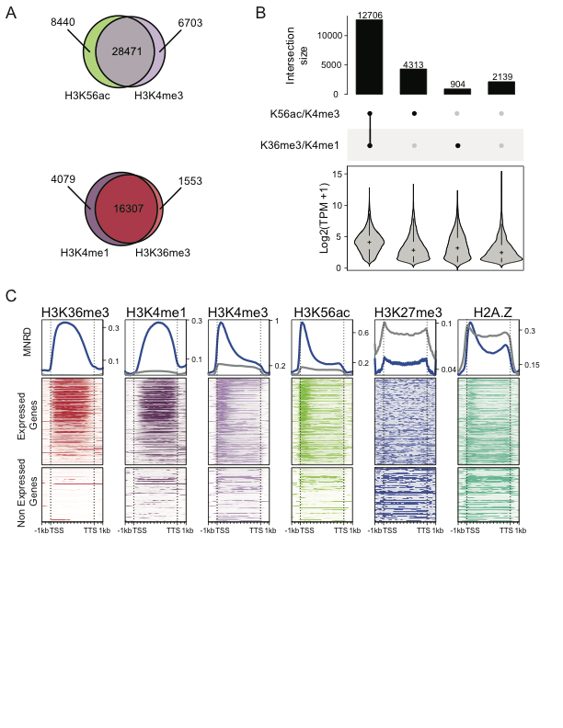

**Supplementary Figure 1.2: The histone modification landscape of expressed and unexpressed genes in *Zea mays* in root tissue.** A) The overlap between enriched domains for either H3K4me1 and H3K36me3 (elongation modification) or H3K56ac and H3K4me3 (transcription initiation modifications). B) Upset plot with number of genes with greater than 1 TPM, and their intersection with histone modifications associated with either transcription elongation and transcription initiation. C) Metaplot profiles of expressed (gray) and unexpressed genes (blue).

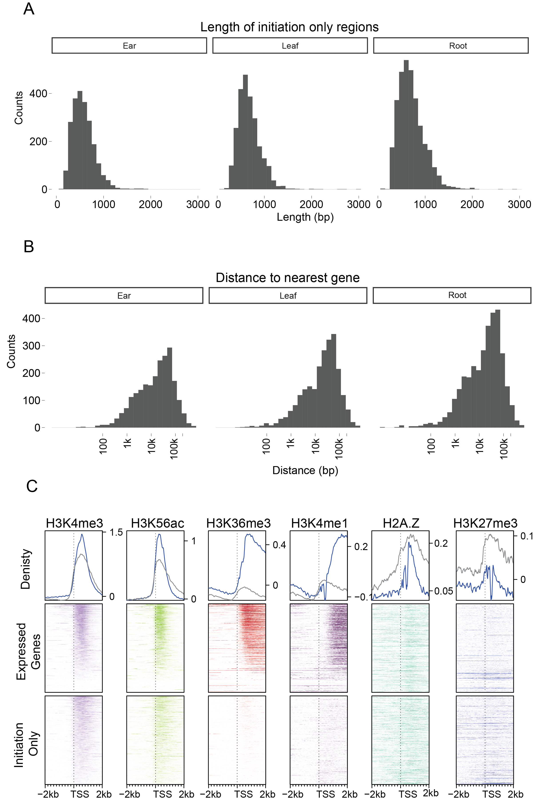

**Supplementary Figure 1.3: Features of genomic regions associated with only initiation modification enriched domains** A) The average size distribution initiation only peaks across three different tissue types. B) Histograms of the distance to nearest gene across three tissue types. C) Metaplots of the initiation only class of genomic regions found in leaf (top gray line), as compared to an equal, random sample of actively transcribed genes (top blue line).

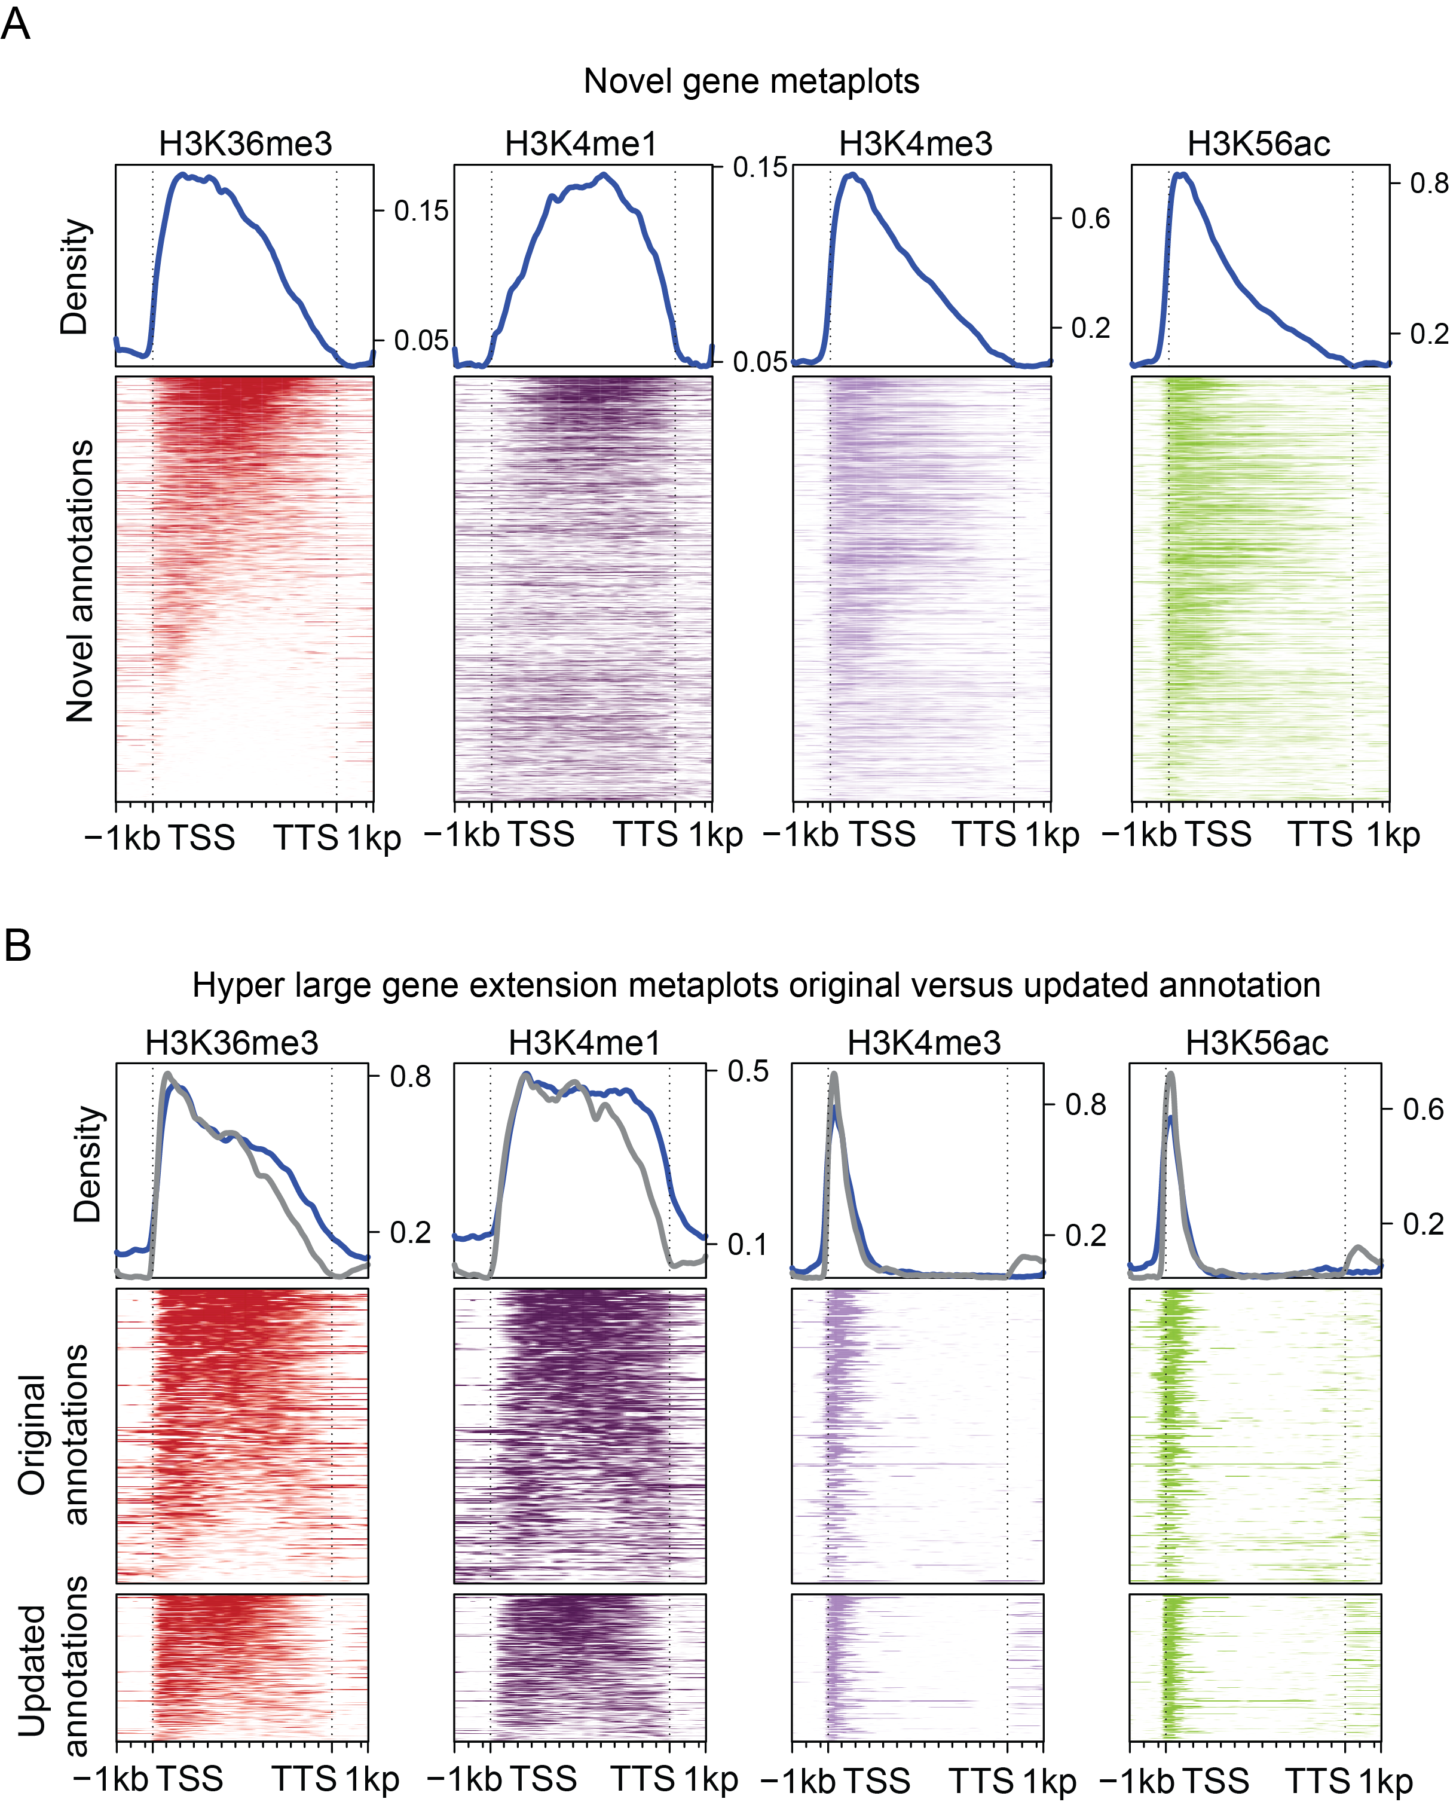

**Supplementary Figure 1.5: Histone modification profiles of altered class of novel and hyper large annotation classes** A) Metaplots of novel annotations which were able to assemble transcripts. B) Metaplots of the hyper large gene class before and after re-assembly. The gray line represents the updated annotations, whereas the blue line represents the original annotations

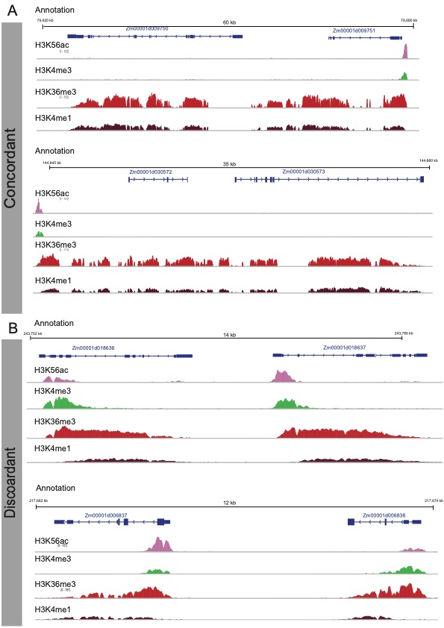

**Supplementary Figure 1.8: Examples of annotation in Monnahan et al with histone modifications which either agree or disagree with the calls made by our method** A) Examples of gene mergers found in both Monnahan et al. and the merger class identified in this manuscript. Histone modification data clearly shows single transcriptional units with enrichment of initiation modifications at the TSS, and elongation modifications extending throughout the gene body. B) Two examples of annotations from Monnahan et al. which disagree with the mergedr annotations identified in this manuscript. The two loci presented here clearly show histone modification demarcating two independent transcriptional units with both initiation modifications at the TSS’s and elongation modifications throughout the gene body

**../03.Figures/Figure_final/supplamental_figure_9_mohaan_et_al_agree_disagree.pdf**

**Supplementary Figure 1.7: Examples of where our annotation method lends additional evidence to unknown regions identified in Monnahan et al.** A-D) Examples of “Non called” gene mergers found in Monnahan et al The histone modification data for all four presented points towards each loci being a single transcriptional unit.

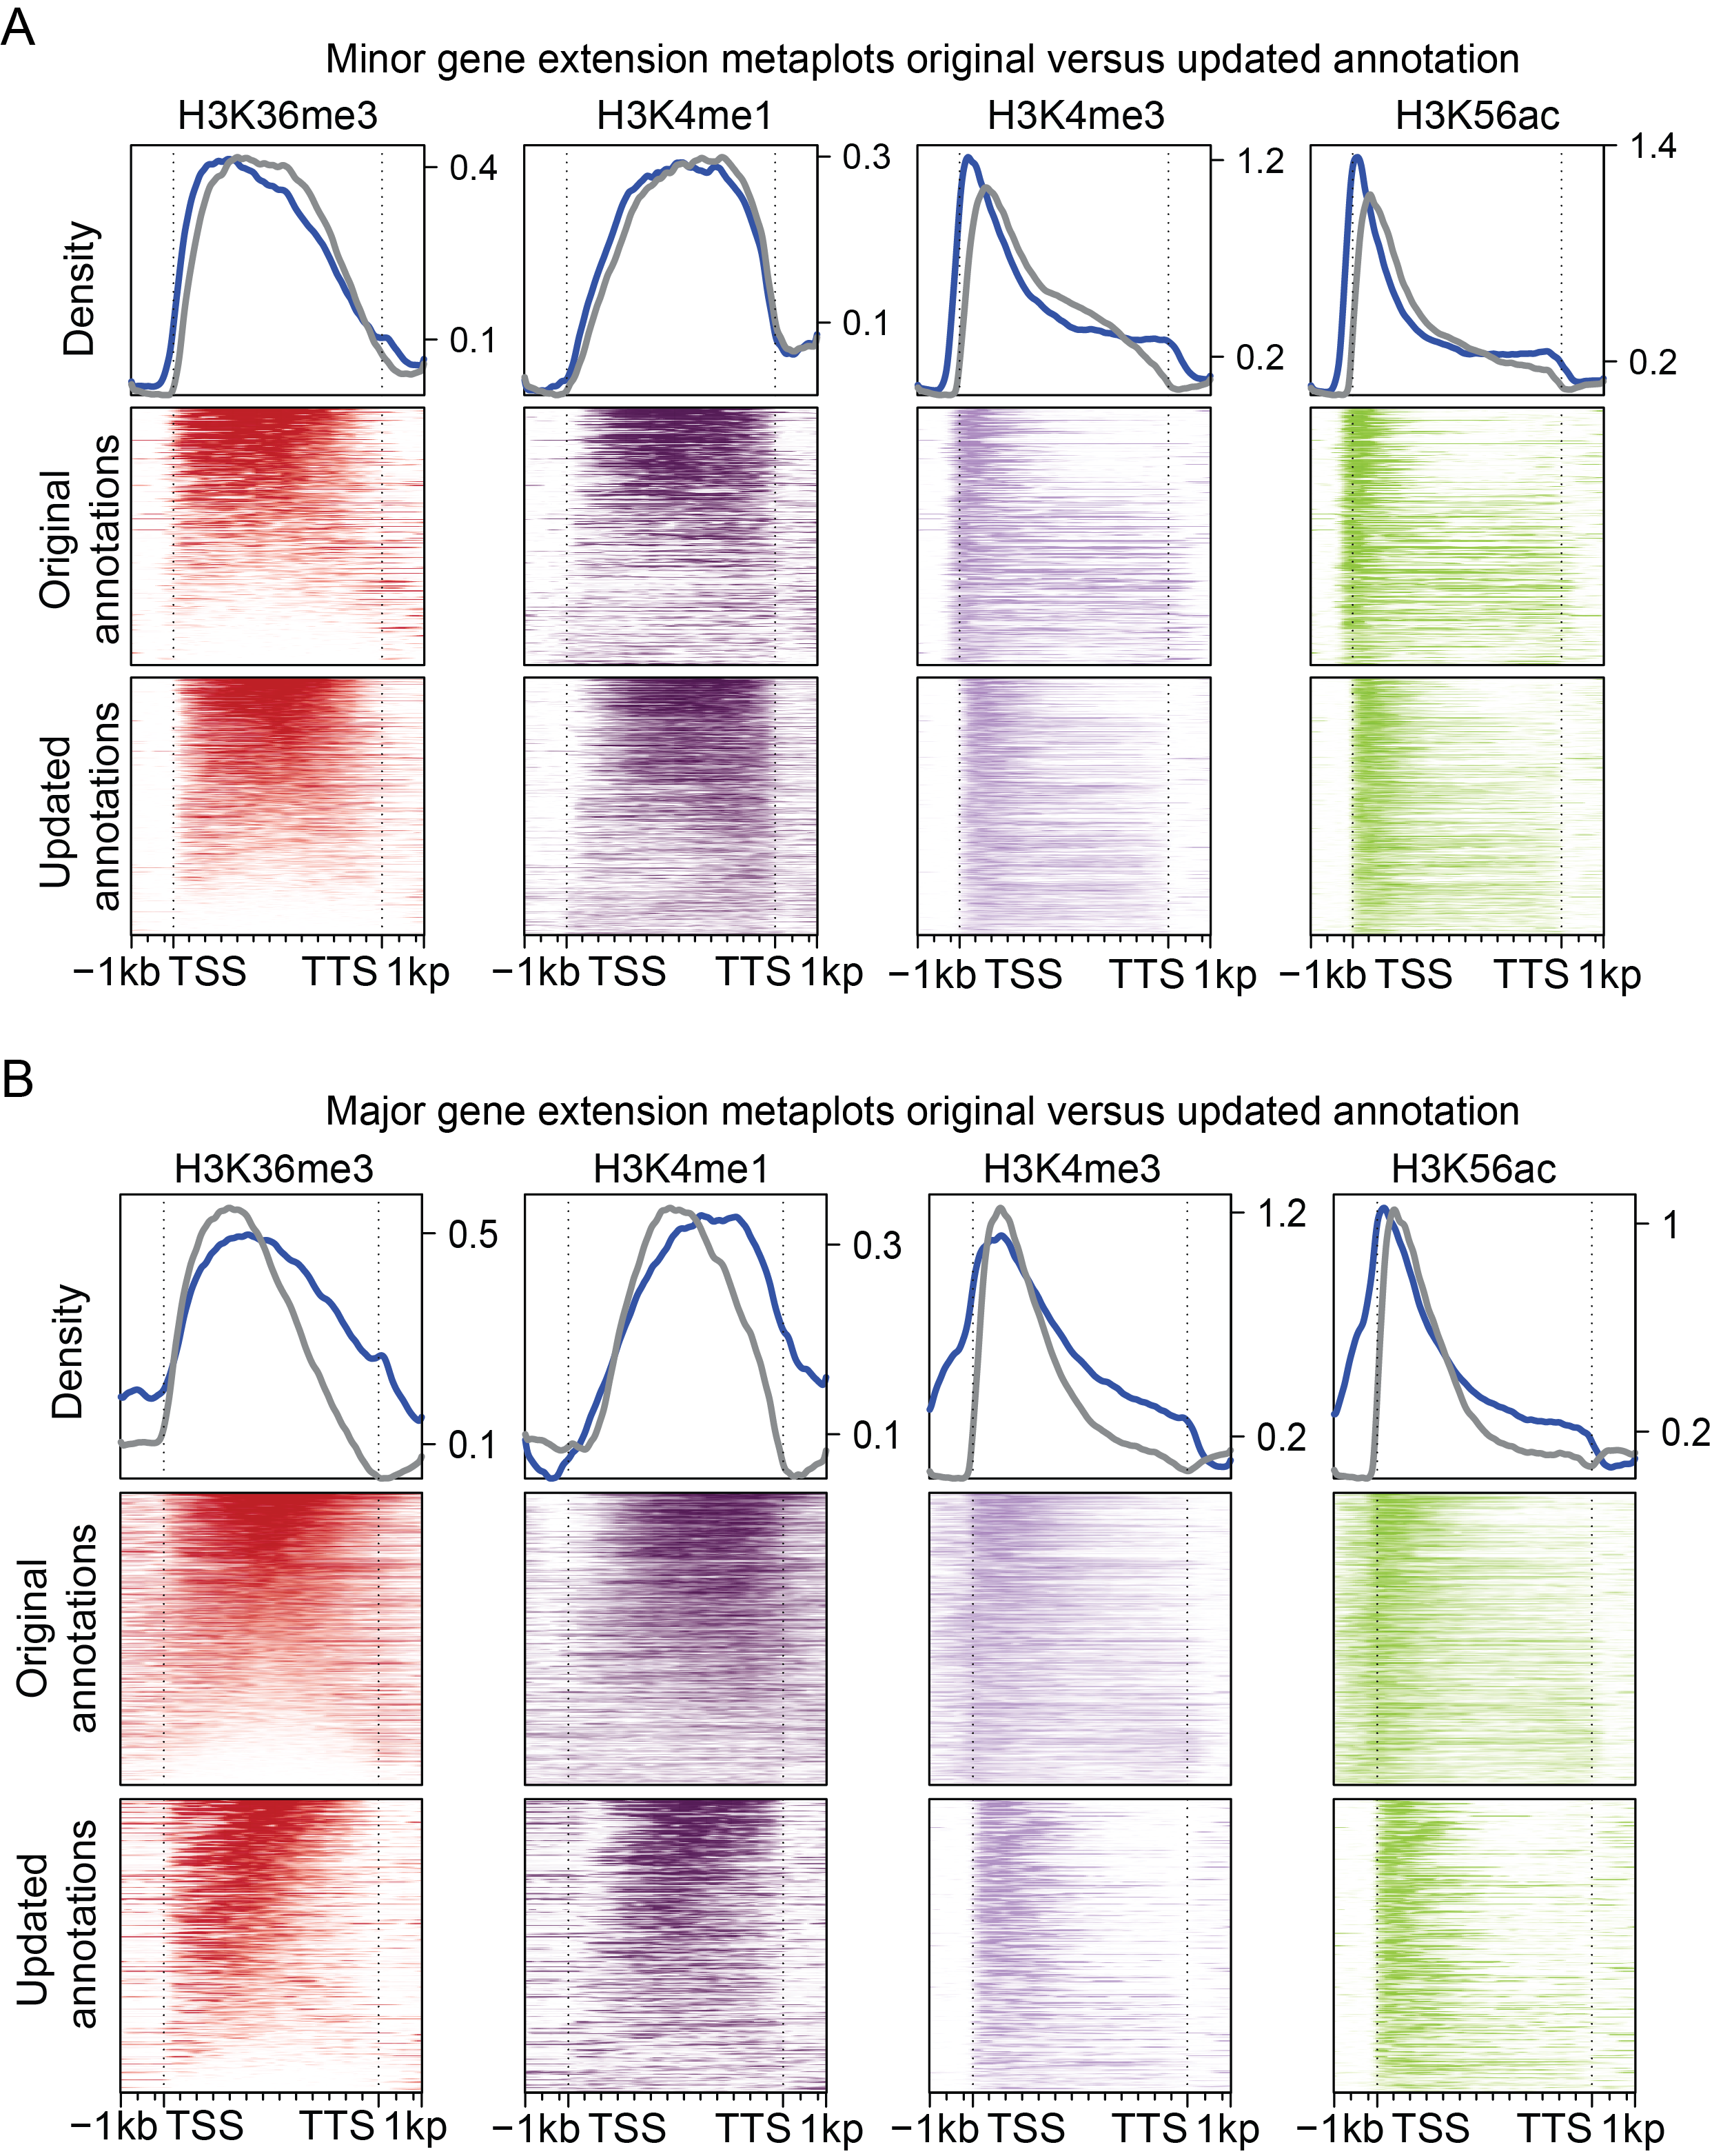

**Supplementary Figure 1.6: Histone modification profiles of major and minor extension annotation classes** A) Metaplots of major class before and after re-assembly. The gray line represents the updated annotations, whereas the blue line represents the original annotations. B) Metaplots of minor extension class before and after re-assembly. The gray line represents the updated annotations, whereas the blue line represents the original annotations

|  |
| --- |
| Species Name |
| *Asparagus officinalis* |
| *Asparagus officinalis* |
| *Asparagus officinalis* |
| *Asparagus officinalis* |
| *Asparagus officinalis* |
| *Phaseolous vulgaris* |
| *Phaseolous vulgaris* |
| *Phaseolous vulgaris* |
| *Phaseolous vulgaris* |
| *Phaseolous vulgaris* |
| *Setaria viridis* |
| *Setaria viridis* |
| *Setaria viridis* |
| *Setaria viridis* |
| *Setaria viridis* |
| *Sorghum bicolor* |
| *Sorghum bicolor* |
| *Sorghum bicolor* |
| *Sorghum bicolor* |
| *Sorghum bicolor* |
| *Glycine max* |
| *Glycine max* |
| *Glycine max* |
| *Glycine max* |
| *Glycine max* |
| *Zea mays* |
| *Zea mays* |
| *Zea mays* |
| *Zea mays* |
| *Zea mays* |
| **Supplementary Table 1.3: Counts of each annotation class found in the five genomes sampled. Unaltered annotations were excluded from this table.** |

**../03.Figures/Figure_final/supplamental_figure_7_merged_gene.pdf**

**Supplementary Figure 1.4: Examples of merged gene sets found, and the post correction, validated assembly.** A) Gene merger 64 B) Gene merger 106 C) Gene merger 17



**Supplementary Figure 3: Features of genomic regions associated with only initiation modification enriched domains** A) The average size distribution initiation only peaks across three different tissue types. B) Histograms of the distance to nearest gene across three tissue types. C) Metaplots of the initiation only class of genomic regions found in leaf (top gray line), as compared to an equal, random sample of actively transcribed genes (top blue line).